**KERALA COLLEGE SPORTS LEAGUE**

**INTRODUCTION**

‘Study Abroad’ boom will be a serious threat to states like Kerala in the future due to various factors like vacant seats and drop outs in our higher education institutions and the return and unemployment of foreign-educated youth. Even, many elite higher education institutions of Kerala and the rest of India have vacant seats. Unemployment and lack of employability among the highly educated are also a serious threat to our society. It is high time to enhance the employability of our graduates and employment opportunities by enhancing the quality of our campus life by giving our students world-class campus experiences.

The legacy of Kerala college sports is also declining day by day due to many reasons such as our failure to adopt the changes took place in the domain of sports and lack of adequate match experiences for our athletes.

**STUDY IN KERALA - REBRANDING OF KERALA CAMPUSES THROUGH COLLEGE SPORTS LEAGUES**

The college sports system is the one major factors which is making foreign countries a preferred education destination. The revolutionary initiative, 'International Sports Summit Kerala 2024', has reached the masses at the root level for a paradigm shift in Kerala's sports canvas. This change can be a catalyst to our higher education institutions by introducing College Sports Leagues in our campuses. It will make a great impact not only in our higher education system, but also in our overall education and sports ecosystem.

**AIMS AND OBJECTIVES**

1. To make Kerala the most preferred learning destination for the students of the rest of India and the world under STUDY IN KERALA branding.
2. To give student-athletes of Kerala maximum high-intensity match experiences to compete with the super champions of various sports
3. To develop more entrepreneurs from Kerala campuses and to enhance the success rates of startups by imparting enterprising skills to the students who are involved in the daily management of college sports clubs
4. To create new employment opportunities
5. To create new revenue opportunities for the colleges to manage their sports programme without government aid
6. To enhance academic success rates of student-athletes
7. To promote sports as an entertainment choice for the students and the public
8. To ensure 100% admissions and reduce dropouts

**IMPLEMENTATION STRATEGY**

College Sports Leagues are a combination of yearlong tournaments of various sports among the member colleges mainly in home and away formats to give students maximum sports-life experiences during their college days and to make Kerala the most preferred learning destination for the students of the rest of India and the world.

The Government of Kerala will act as the promoter of College Sports Leagues in Kerala by establishing a special organization as the league organizer to promote, design and organize College Sports Leagues of various sports among universities and colleges of Kerala.

Colleges will establish Colleges Sports Clubs as a charitable or cooperative society and will function as a sports team in the proposed leagues. The daily activities of the college sports clubs will be managed by students under the guidance and supervision of competent faculty.

The league organizer will design the league and prepare the fixture in consultation and with the consent of the member college sports clubs.

In the first year, the league will be conducted with a minimum number of colleges and within minimum days. Due to the climatic conditions of the Kerala state, the pilot league can be introduced with indoor sports like football, basketball, volleyball, kabaddi or badminton. In the first-year, the league can be conducted with one university or limited number of colleges from each university to avoid the difficulties due to the conflicting academic calendars.

In next five years, the College Sports League system of Kerala will be developed to a full-fledged pyramid format (open league system) in which the winners of the bottom levels shall be qualified to participate in the upper level.

**PROCESS**

The college sports leagues can be kick-started as shown in the below infographic.

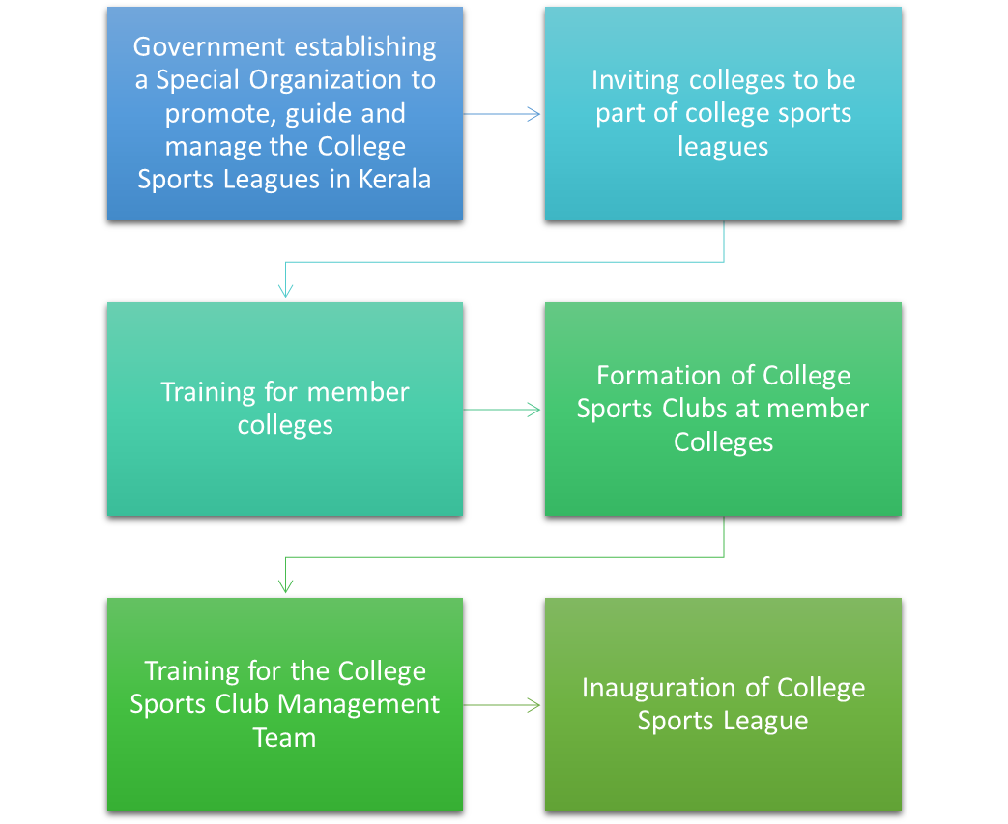

**GOVERNING BODY**

* The government shall establish a special organization (SO) registered as a charitable society or cooperative federation to promote, guide and manage the College Sports Leagues in Kerala.
* Stakeholders of the college sports leagues such as the official representatives of colleges, universities and department of sports shall be the members of this special organization
* This special organization shall be responsible for developing the Standard Operation Procedures (SOP) and to ensure its adherence
* The SO shall be responsible for preparing the overall structure of College Sports Leagues in Kerala and its fixtures.
* The SO shall function as a commercial organization and shall generate operational revenue for its existence and excellence.
* The Government shall support the SO in the initial years with refundable grants and the SO shall repay these grants within 5 years
* The SO shall appoint competent professionals from different sports domains such as sports management under the leadership of a CEO to manage the daily operations of the organization and shall be responsible for the profit and loss of the organization
* The overall successful management of the league is the primary responsibility of the special organization
* The SO shall be responsible for upholding the standards and brand values of the League.
* The SO shall coordinate the promotion activities to ensure maximum attendance on game days
* The SO shall ensure overall security in venues
* The SO shall have the leadership of the ‘College Sports League Movement in India’ and ‘Study in Kerala’
* The SO shall train the Member Colleges in sports management aspects such as Team Management, Fan Management and Game Day operations
* The SO shall be responsible for ensuring the overall quality of the league
* The SO shall provide student-athletes maximum opportunities to learn, compete and grow on and off the field
* The SO shall be responsible for enhancing the graduating rates of student-athletes
* The SO shall support student-athletes to get openings to professional sports
* The SO shall create new employment opportunities by promoting the college sports leagues to more colleges and more sports
* The SO shall work to enhance the quality of college life for our students by offering them better sporting opportunities and better work experiences
* The SO shall arrange strategic tie-ups with various sports leagues and professional sports clubs to widen the opportunities for players participating in the college sports leagues and to increase the scalability of the league

**MEMBER COLLEGES**

The colleges agreeing to participate in the college sports leagues by paying a membership fee fixed by the SO shall be known as Member Colleges.

**Roles & Responsibilities**

* Preparation of the field and other infrastructure for the home matches in compliance with the rules and regulations of the League.
* Arranging permanent/ temporary dressing rooms for the home and away teams
* Arranging lodging for the away team, if a common lodging partner is not available
* Ensuring the security of the away team
* Conducting league and matchday-related promotional activities inside and outside the college
* Ensuring the maximum number of spectators from the college
* Selection and practice of the college team
* Finding out sponsors for home team and home ground branding
* Logistics of college team for away matches
* Connecting with alumni and prospective students
* Formation of a College Sports Club for the overall management of college-level sporting activities.
* Member Colleges shall not quit the league during the league season
* Member Colleges shall not boycott any match due to any reason

**COLLEGE SPORTS CLUBS**

* Each member college has to form a College Sports Club for the successful management of the league at the college level
* This College sports club has to be registered as a charitable society or cooperative society.
* This college sports club shall be considered as a Sports Startup (Sportup)
* The college sports club board of directors shall include representatives of college management, principal, departments of Sports (Physical Education), Commerce and Management, Students Union and Alumni Association
* In the case of colleges without departments of sports, commerce and/or management, faculty from other departments shall be included in the board of directors
* Representatives of the Students’ Union shall be selected along with the College Union election
* The Department of Sports (Physical Education) shall be responsible for team management (selection, practice and logistics) and game management (field preparation and game management
* Department of Commerce and Management shall be responsible for revenue generation (sponsorship, partnership, donations, merchandise sales etc) and the matchday management
* The chairperson of the College Sports Club shall represent the member college in the SO.
* The College Sports Club shall be responsible for designing and executing various promo activities to engage students with the League

**COLLEGE SPORTS CLUB MANAGEMENT**

* The daily management of College Sports Clubs shall be done by the selected students under the guidance of trained faculty/staff
* It shall be an EARN WHILE LEARN opportunity for the students. The students engaged in the College Sports Club Management shall be given stipends and performance bonuses for their services
* The faculty involved in the management of College Sports Club Management shall be rewarded with performance bonuses for their services
* The students shall be selected for the College Sports Club Management through an Aptitude Test

The following committees/departments shall be formed to manage the activities of the College Sports Club (Their major responsibilities are mentioned below)

1. Team Management

Team selection

Training

Home match coordination

Away match coordination

1. Marketing Management

Sponsorships

Partnerships

Donations

Other fundraising activities

Branding

1. Merchandise Management

Product Development

Sales Channels Management

1. Public Relations Management

Media management

Social Media

Public Engagement Activities

Fan Engagement

Cheerleading

Ceremonies

1. Operations Management

Match Day Operations

Refreshments

Hospitality

Logistics

Medical Support

Security

1. Finance Management

Financial Management

Accounting

Auditing

1. Game Management

Pitch Preparation

Refereeing

Commentary

Ground Support

1. Sports Facility Management

Daily management of sports facility

Equipment management

Membership Management

Member Engagement

**TEAM SELECTION**

* College Sports Clubs shall (must) select players from the current degree/ post-graduation students of the college
* No guest player shall be allowed
* The maximum age of the player shall be 25
* Student-athletes of Amateur/professional athlete status shall be allowed to be part of the team.
* A student-athlete shall represent the college in a college sports league only if the student has acquired the designated number of credits at the end of each appropriate semester.
* The students who get study extensions beyond their normal academic years under sports performance shall not be allowed in the College Sports Teams
* The student-athletes shall be rewarded with stipends and performance bonuses
* The selection process shall be transparent
* The selection process shall adhere to the guidelines of the SO.

**MEETING**

Hon. Sports Minister Shri. V Abdurahamn and Hon. Higher Education Minister Dr. R Bindu jointly held the meeting at Higher Education Ministers chamber on 22.05.2024, to discuss about the implementation of College leagues in Kerala. As per the decision of this discussion, a Committee was formed to discuss the scope, feasibility and possible implementation of College Sports League in Kerala and a meeting was held on 06.06.2024 at 11 AM under the chairmanship of Director, Sports &. Youth Affairs at the Jimmy George Indoor Stadium conference hall.

The meeting was attended by the Kerala State Sports Council president, experts in the field including various university physical education directors and other members.

The Director, DSYA presented the College Sports League project proposal in detail, explaining the need and necessity of such a league apart from the conventional college sports tournaments. He briefed that the successful college sports leagues implemented abroad can be a model for consideration, and this will be the first time in India if such a programme is implemented. The members in the meeting reiterated that the College sports league is a novel idea and needs to be implemented professionally after careful consideration and study.

The Director also informed of the need for the formation of a governing body and various committees.

Meeting discussion points and suggestions

1. The schedule in the sports calendar is tight, hence the programme may need to be limited to a window of 3 months.
2. The college sports league should have a USP compared to the already existing sports tournaments in the state. Since many competitions exist, players need to compromise that for the league.
3. The initial pilot project to launch 3 to 4 games – Football, Volleyball, Basketball, Badminton/Athletics.
4. A detailed study of the prospects of the mentioned income generation, time schedule, employability, venues, quality of league, spectator value, broadcasting and live streaming, marketing etc to be made.
5. A feasible league structure needs to be identified. Proposed structure – divide colleges in the state into zone-wise clusters and conduct the district college league. Winners of the clusters to take part in the state college league.
6. The cluster to have a minimum of 8 teams from a major university and if there are more colleges from a particular zone, the number of clusters to be increased.
7. A registration fee of Rs. 5000/- to be charged for teams sports as registration fee.
8. The concerned State, District associations of the respective sports and the District Sports Councils to be actively involved in the supervision and liaison of the league.
9. There are colleges in the state that want to play more matches per season and hence this is a good opportunity for them.
10. League matches to be conducted on weekdays, with one match in week for a team.
11. The college sports league squad size is to be maximized. Hence the teams can manage inter-collegiate, zonal tournaments along with the college sports league. More players including junior players get an opportunity to represent their teams in the college sports league.
12. All colleges in Kerala need to form sports clubs, the direction of the same is to be given. These sports clubs to help in implementation and various aspects of the college sports league. Such sports clubs will involve in various aspects of the league like event management, marketing, media promotions etc. These Sports clubs will also help in developing the sports culture at colleges in Kerala, inspire sports incubators, sports startups and also enhance the overall development of sports in colleges in Kerala.
13. League has the potential for huge news value, with league winners to be presented with prize money
14. A title sponsor to be identified at state level to associate with the college sports league.
15. A governing body to be formed at the state level with the Hon’ble Chief Minister as the chief patron and the Hon’ble Sports Minister and Hon’ble Minister for Higher Education as Co-patrons.

**Recommendations**

* A Governing body for the College Sports League to be formed at the state level. Technical committees, district committees and other operating wings to be formed under this governing body. The members of the governing body to also include University physical education directors, State presidents of respective sports associations. Representatives from KSSC, Sports Management professionals, Data analysts, Sports medicine representatives etc. An SoP of the league to be prepared by the committee
* Proposal to be submitted to Govt. to launch the College Sports League pilot project which will include 3 to 4 mainstream games. The proposal to be approved as a pilot initiative.
* Meetings of VC’s/Registrars may be convened by the Honorable Minister to present the ideas once the norms are finalized.
* Administrative costs to be met from both departments allocation. There shall be certain fund allocation in the initial years.
* Event management teams shall be on boarded for the overall coordination and publicity through SKF.

# ANNEXURES

# College sports league format

# Event management team roles & responsibilities

# College Sports League Format

# Structure I- Proposed by SMRI- 8 Teams

**Two Zones- 4 teams each**

Total Matches- 25

Total Match days-13 (2 matches per day)

# Structure II- All Colleges – 1000 Colleges

**Cluster Leve**l- 4 Colleges Meet in League format

Total Matches- 12 matches; 6 for each team (6 Match days)

Each District will have 5 to 20 clusters depending on the number of colleges in a district.

**District Level-** All winners of cluster level to qualify for District level Number of teams- Vary from 5 to 20

Number of matches- Vary from 20 to 380 (upto 38 match days)

**State Level-** All winners of District Level qualify for the State Level Number of teams- 14

Number of matches- 182 (26 match days)

# Total Match days- 70

**Structure III- 80 Colleges**

**Cluster Leve**l- 4 Colleges Meet in League format

Total Matches- 12 matches; 6 for each team (6 Match days)

**Zonal Level-** State to be divided into Four Zones of 5 clusters each Number of teams- 5

Number of matches- 20 (8 for each team, 8 match days)

**State Level-** All winners of Zonal Level qualify for the State Level

Number of teams- 4 at a single venue round venue

Number of matches- 7 including Final (4 match days)

# Total Match days- 18 Total Matches-327

# Structure IV– N number of Colleges

**District level cluster**- 4 teams in a group league format (N number clusters in a district)

Total matchdays – 6

**N number of cluster winners** – 4 teams in a group league format

Total matchdays – 6

14 district level winners

**Zonal league (North, North central, South central, South)**

Total matchdays – Maximum 6

| North | North Central | South Central | South |
| --- | --- | --- | --- |
| Kasargod  Kannur  Wayanad  Kozhikode | Malappuram  Palakkad  Trissur | Ernakulam  Idukki  Kottayam | Alappuzha  Pathanamthitta  Kollam  Trivandrum |

# State level super league – 4 zonal winners in league format

# Total matchdays – 3

# Total matchdays - 21

1. **Event management team**

**Roles & responsibilities**

For organizing and coordination of All Kerala inter collegiate sports league in the following disciplines:

Football

Basketball

Cricket

Badminton

1) Detailed event plan and fixtures.

2) Financial implication

3) Website development/ registration and online payment system

4) Event Marketing/ sponsorship

5) Event management

6) Social media promotions

7) Tie-ups with radio/ online media/ streaming partners/ satellite channels.

8) Co ordination with government machinery, training of sports clubs in colleges etc.